|  |
| --- |
| **What is Voiceitt?** |

**Adapt-IT are here to support you every step of the way of your Voiceitt journey!**



**Voiceitt is a powerful web app for people with speech disabilities that translates their non-standard speech into audio and text outputs for both in-person and virtual communication. Created in collaboration with individuals with atypical speech and speechlanguage pathologists, Voiceitt has opened previously inaccessible Voice AI solutions for communication, dictation, home automation, and more.**

|  |  |
| --- | --- |
| **Training Voiceitt** |  |
| **Voiceitt starts everyone with a free 30-day trial. After signing up, the first step is to teach Voiceitt your unique speech patterns by recording training phrases. Voiceitt requires 50 recordings minimum to unlock the ‘Speak’ and ‘Dictate’ modes. You can change which level of difficulty your training phrases are within the recording tab.**  **However there is a levelling system with 8 levels that determines your accuracy based on how many phrases you have recorded.**  **The levels are:**  **Level 1 – 50 recordings – “Hi I’m Voiceitt. Nice to meet you.”**  **Level 2 – 100 recordings – “Voiceitt is getting to know your voice better.” Level 3 – 200 recordings – “Voiceitt is starting to learn your speech patterns.”**  **Level 4 – 300 recordings – “Voiceitt is a beginner listener.”**  **Level 5 – 400 recordings – “Voiceitt is an intermediate listener.”**  **Level 6 – 600 recordings – “Voiceitt is a familiar listener.”**  **Level 7 – 800 recordings – “Voiceitt is an advanced listener.”**  **Level 8 – 1000 recordings – “Voiceitt is an expert listener.”** |

**www.adapt-it.co.uk 03300 564079**

# Speak Mode

**Once you have completed 50 training phrases, you will unlock the ‘Speak’ mode. The ‘Speak’ mode is speech-to-speech for interacting with others and smart home systems.**

**To use Speak, select “Click to speak”, and speak a short phrase, for example, “Can I have a cup of tea?”. Then select the “Listening: tap to stop” button and Voiceitt will speak what you said in a clear computerised voice. You can change your voice in the Menu drop-down under Settings.**

**Speak also has a built-in toggle to engage directly with ChatGPT. Go ahead, and ask ChatGPT a question!**

**To toggle between ‘Speak’ and ‘Dictate’, just tap the ‘Switch Mode’ button.**

**Dictate Mode**

**You will also unlock the ‘Dictate’ mode once you have reached 50 training phrases.**

**The ‘Dictate’ mode is speech-to-text. You can speak a story and let someone read your screen or dictate an email using copy-and-paste or share to another location.**

**Dictate has Voice Control for hands-free editing and navigation, or you can edit the text by typing. Dictate also offers ‘Notes’ to return to a previous message.**

**Dictate can speak by tapping ‘play’ or delete the text on the screen by tapping ‘clear’.**

# Voice Controls and Text Formatting

**Within the ‘Dictate’ mode, there is a setting that enables voice controls that allows you to use your voice to complete actions and format your text.**

**From copying and pasting to inserting exclamation marks, you can ensure your text is correct before you share.**

**In the top right corner you can click on “Voice Controls” and “Text Formatting” to see the lists of options and how to activate them.**

# Handsfree Training

**Within the training mode, there is the option to enable hands-free training. This allows people with limited mobility to cycle through each stage of the training without having to continuously press buttons. There are 5 different settings; Auto record, auto listen, auto play, auto submit and speed and each of these can be toggled separately to allow the user to customise it to their specific needs. The speed setting relates to the delay between each action completing and going on to the next.**

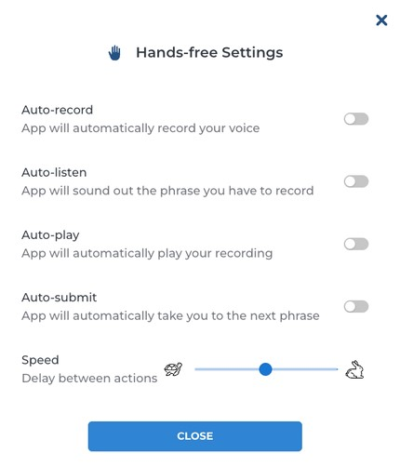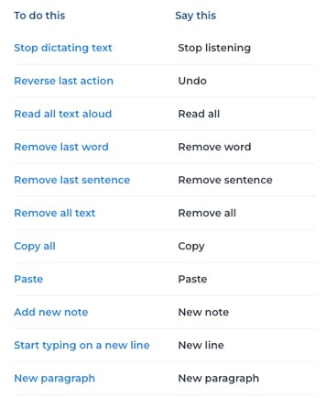

# Google Chrome Extension

**The Voiceitt Chrome extension is speech-to-text input designed by and for people with non-standard speech. It allows you to dictate directly into Google Chrome.**

**Chrome extensions are for use on the Chrome browser on a laptop or desktop device. They do not work on tablet or mobile (e.g., iOS or Android) devices or other browsers (e.g., Safari & Edge).**

**Voiceitt Chrome Extension works on various websites, but not all of them. New websites are added everyday but please contact us if a website that is important to you does not allow you to dictate.**

**To use the Voiceitt extension, you need an active Voiceitt subscription with at least 50 recordings completed.**

# Integrations

**Voiceitt integrates with Microsoft Teams and Zoom which allows live personalised closed captioning during video calls.**

**Whether it’s a work call, calling your family or catching up with friends, Voiceitt captions ensures everyone can follow along and participate effectively.**

**The Teams capabilities require a paid Microsoft 365 account to add the Voiceitt Captions from the app menu.**

**An active Voiceitt account is required for Voiceitt Captions for both Teams and Zoom. Guests are able to view the Voiceitt Captions.**



**Accessibility**

**Examples**

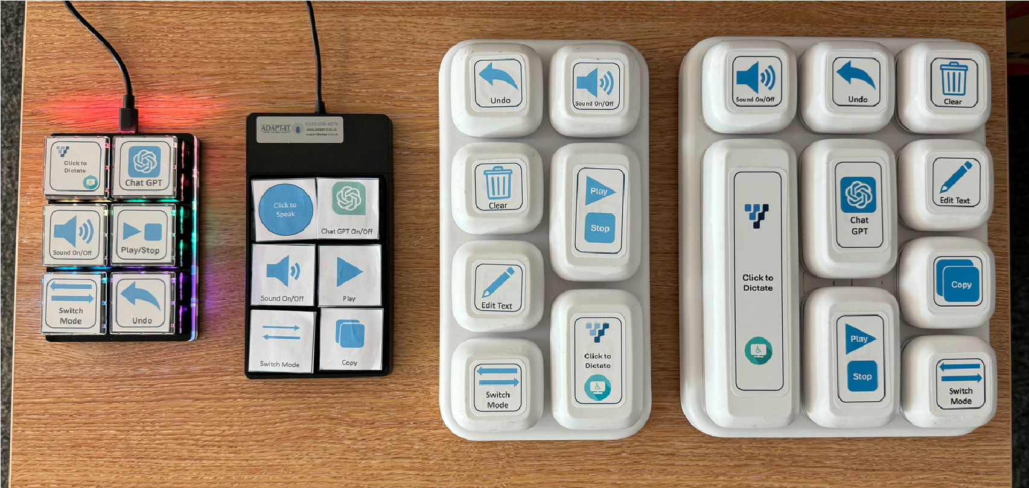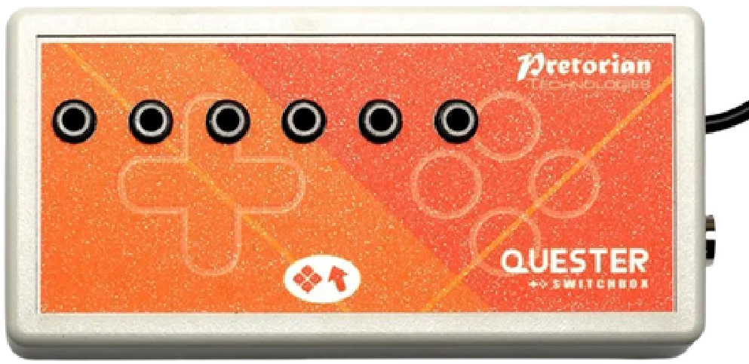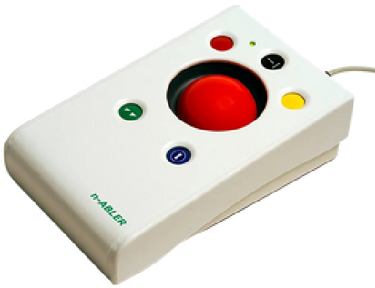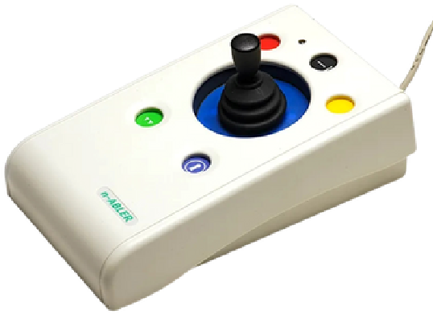

**Voiceitt**

**has**

**keyboard**

**shortcuts**

**associated**

**with**

**each**

**button**

**which**

**allows you to be able to not only use a keyboard, but also break the**

**buttons out. With the power of programmable keyboards and assistive**

**switches and switch boxes, each button can be made to be as big or**

**small as necessary as well as mounted in suitable places.**

**Another option for controlling Voiceitt is via alternative mice such as**

**joysticks, trackballs or even eye gaze. These would provide comfortable**

**access to not only Voiceitt but to the computer and the internet as a**

**whole.**

**Mounting the device you’re using Voiceitt on, as well as the assistive**

**tech to control it, is key not just for comfort but also for effective and**

**reliable use.**

|  |  |  |
| --- | --- | --- |
|  | **Consent Forms** | **There is no age restriction for Voiceitt, however, Adapt-IT, the UK Partner**  **Consent Form to be filled in by the Parent/Guardian for users under the age of 16, so that we comply with UK**  **In return, they will receive a Consent Form via email from Adapt-IT that This way, Adapt-IT will inform Voiceitt that a Consent Form has been**  **N.B It must be the Parent/Guardian of the Young Person. We cannot accept Consent Forms signed by a Professional such as a Teacher or**  **The Parent/Guardian email address will only be used for Consent Form purposes. The Parent/Guardian will receive no further communication Should you have any questions or concerns about this process, you can**  [**k**](http://www.adapt-it.co.uk/) |
| **of Voiceitt, do require their**  **GDPR.**  **Please contact:**  **voiceitt@Adapt-IT.co.uk and let us know the following details:**    **The Parent/Guardian email address.**  **is to be digitally signed. appropriately signed and the account will be unlocked.**  **SLT/OT.**  **from Adapt-IT unless requested.**  **contact us in the following ways:**  **Email: Voiceitt@Adapt-IT.co.uk**  **Telephone: 03300 564079**  **Visit our Website:** [**www.Adapt-IT.co.u**](http://www.adapt-it.co.uk/)  **We will be happy to help.** |

**Consent Forms**

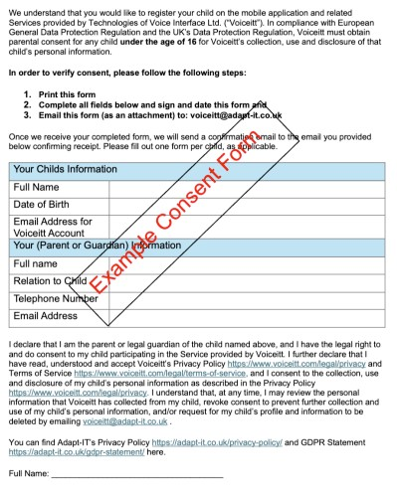

|  |  |  |  |  |  |  |  |  |
| --- | --- | --- | --- | --- | --- | --- | --- | --- |
|  | **Pricing** | | | |  | |  | |
|  | | | |
|  | **License**  **Type -**  **Per User** | **1-9 Users** | **10-49 Users** | | **50-99 Users** | **100+**  **Users** |  |
| Monthly | £45 | £45 | | £45 | Call for pricing |
| Annual | £450 | £400 | | £350 | Call for  pricing |
| 5-Year | £1350 | £1200 | | £1050 | Call for pricing |
| Prices are excluding VAT. | | | | |  |

**Have you got questions regarding Voiceitt?**

Visit our FAQs page or contact us on:

Web Chat

Web Form

Email – voiceitt@adapt-it.co.uk

Telephone – 03300 564079

**We’ll be happy to chat to you and ensure your questions are answered!**